This first plot shows the scores on the x axis and the price on the y axis.

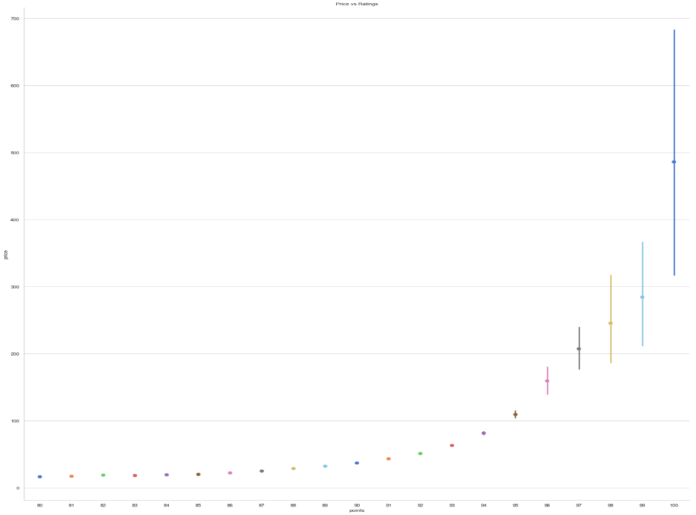

The bar graphs below show how the countries of origin set their price and how they are being scored.

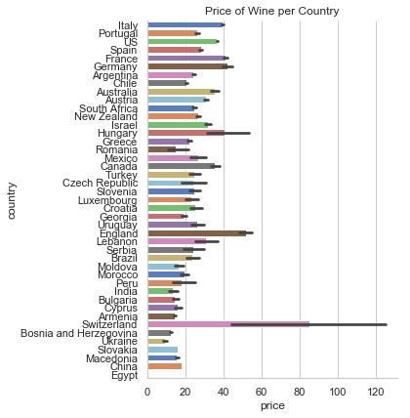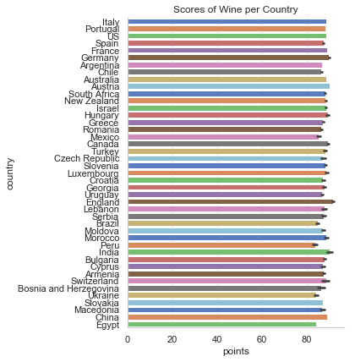

The text from the reviews were extracted. Certain words that will not give insight on word usage were taken out (ie: the word ‘wine’). The entries with the highest scores represent the favorable words, such as, ‘fruit,’ ‘rich,’ ‘spice,’ ‘complex,’ and ‘aroma.’ The entries with the lowest scores shows words, such as, ‘aroma,’ ‘acidity,’ ‘bitter,’ and ‘simple.’

